Table 1: Census data description, year 2010 2

Table 2: NO2 concentration by strata 2

Table 3: Childhood asthma survey summary 3

Table 4: Comparing results of the burden of disease using state-specific estimates with original estimates 3

Figure 1: Childhood asthma incidence rate flow chart. 4

Figure 2: Attributable fraction by median income grp stratified into living location 5

Figure 3: Attributable fraction by state 5

Figure 4: Attributable fraction by state and living location 6

Figure 5: Attributable fraction by state and median income group 7

Table 1: Census data description, year 2010

|  |  |  |
| --- | --- | --- |
| **Geographic characteristics** | **Total populated census blocks** | 6,182,882 |
| **Total census-designated urban areas** | 3,590,278 |
| **Demographic characteristics** | **Total population** | 306,675,006 |
| **Total population of children (birth – 18)** | 73,690,271 (24%) |
| **Mean (range) number of children in census blocks** | 12 (0-2214) |
| **Population of children by living location** | **Rural** | 13,763,183 (19%) |
| **Urban clusters (≥2,500 and <50,000 people)** | 6,994,464 (9%) |
| **Urbanized area (≥50,000 people)** | 52,932,624 (72%) |
| **Population of children by median household income** | **<$20,000** | 2,614,804 (4%) |
| **$20,000 to <$35,000** | 12,770,843 (17%) |
| **$35,000 to <$50,000** | 18,573,954 (25%) |
| **$50,000 to <$75,000** | 21,953,876 (30%) |
| **≥$75,000** | 17,763,239 (24%) |

Table 2: NO2 concentration by strata

|  |  |  |  |  |  |  |  |
| --- | --- | --- | --- | --- | --- | --- | --- |
|  |  | **Mean** | **Min** | **25%** | **Median** | **75%** | **Max** |
| **Total** |  | 13.2 | 1.5 | 7.9 | 11.4 | 16.6 | 58.3 |
| **By living location** | **Rural** | 8.0 | 1.5 | 6.0 | 7.8 | 9.8 | 37.7 |
| **Urban cluster** | 12.0 | 1.6 | 9.6 | 11.9 | 14.2 | 35.6 |
| **Urbanized area** | 18.4 | 2.6 | 13.0 | 17.0 | 22.1 | 58.3 |
| **By median household income** | **<$20,000** | 16.1 | 2.0 | 10.4 | 14.9 | 20.1 | 56.8 |
| **$20,000 to <$35,000** | 13.2 | 1.6 | 8.1 | 11.7 | 16.7 | 58.3 |
| **$35,000 to <$50,000** | 11.8 | 1.5 | 7.0 | 10.0 | 14.5 | 58.0 |
| **$50,000 to <$75,000** | 12.8 | 1.6 | 7.6 | 10.8 | 15.7 | 55.7 |
| **≥$75,000** | 16.5 | 2.1 | 10.9 | 14.9 | 20.6 | 55.5 |

Table 3: Childhood asthma survey summary

|  |  |  |  |  |  |  |
| --- | --- | --- | --- | --- | --- | --- |
|  | **2006** | **2007** | **2008** | **2009** | **2010** | **Overall** |
| **BRFSS sample (weighted)** | 55,094 (50,674,742) | 59,487 (43,661,381) | 61,862 (53,327,550) | 59,821 (47,747,373) | 57,200 (39,975,264) | 293,464 |
| **Ever asthma sample (weighted)** | 7,168 (6,493,224) | 7,971 (5,763,409) | 8,255 (7,218,400) | 8,126 (6,279,938) | 7,483 (5,158,455) | 39,003 |
| **ACBS Sample (weighted)** | 2017 () | 3924 () | 3924 () | 4095 () | 2196 () | 16,156 |
| **Incident case sample (weighted)** | 154 (404,276) | 173 (312,917) | 169 (385,818) | 153 (297,546) | 160 (319,743) | 809 |
| **At-risk sample (weighted)** | 48,080 (30,825,589) | 51,689 (36,050,557) | 53,776 (26,491,259) | 51,848 (25,942,087) | 49,877 (22,900,850) | 255,270 |
| **Incidence rate** | 13.1 | 8.7 | 14.6 | 11.5 | 14.0 | 12.1 |
| **Prevalence rate** | 12.8 | 13.2 | 13.5 | 13.2 | 12.9 |  |
| **Number of states included** |  |  |  |  |  | 34 |

Table 4: Comparing results of the burden of disease using state-specific estimates vs original estimates

|  |  |  |  |  |  |  |  |  |  |  |  |  |  |
| --- | --- | --- | --- | --- | --- | --- | --- | --- | --- | --- | --- | --- | --- |
|  |  | **Main results** | | | **Original results** | | | **Difference** | | | **Percentage difference** | | |
|  |  | **Incident cases** | **AC** | **AF** | **Incident cases** | **AC** | **AF** | **Incident cases** | **AC** | **AF** | **Incident cases** | **AC** | **AF** |
|  | **Total** | 754,893 | 132,829 | 17.6% | 794,934 | 141,931 | 17.9% | -40,041 | -9,103 | -0.3% | -5.0% | -6.4% | -1.4% |
| **By living location (% of Total)** | **Rural** | 142,559 (19%) | 13,951 (11%) | 9.8% | 148,470 (19%) | 14,466 (10%) | 9.7% | -5,911 | -514 | 0.0% | -4.0% | -3.6% | 0.4% |
| **Urban cluster** | 71,249 (9%) | 9,296 (7%) | 13.0% | 75,453 (9%) | 9,844 (7%) | 13.0% | -4,204 | -549 | 0.0% | -5.6% | -5.6% | 0.0% |
| **Urbanized area** | 541,085 (72%) | 109,581 (82%) | 20.3% | 571,011 (72%) | 117,621 (83%) | 20.6% | -29,926 | -8,040 | -0.3% | -5.2% | -6.8% | -1.7% |
| **By median household income (% of Total)** | **<$20,000** | 28,039 (4%) | 5,834 (4%) | 20.8% | 28,207 (4%) | 5,892 (4%) | 20.9% | -168 | -58 | -0.1% | -0.6% | -1.0% | -0.4% |
| **$20,000 to <$35,000** | 134,208 (18%) | 24,906 (19%) | 18.6% | 137,765 (17%) | 25,794 (18%) | 18.7% | -3,558 | -889 | -0.2% | -2.6% | -3.4% | -0.9% |
| **$35,000 to <$50,000** | 190,481 (25%) | 32,369 (24%) | 17.0% | 200,367 (25%) | 34,549 (24%) | 17.2% | -9,885 | -2,180 | -0.2% | -4.9% | -6.3% | -1.4% |
| **$50,000 to <$75,000** | 223,522 (30%) | 37,559 (28%) | 16.8% | 236,827 (30%) | 40,540 (29%) | 17.1% | -13,305 | -2,981 | -0.3% | -5.6% | -7.4% | -1.8% |
| **≥$75,000** | 178,497 (24%) | 32,133 (24%) | 18.0% | 191,621 (24%) | 35,128 (25%) | 18.3% | -13,123 | -2,994 | -0.3% | -6.8% | -8.5% | -1.8% |

**Figures**

Figure 1: Childhood asthma incidence rate flow chart.

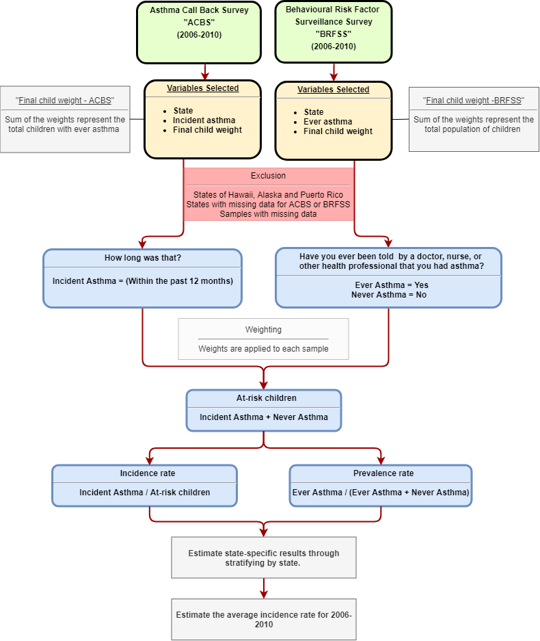

Figure 2: Attributable fraction by median income group stratified into living location

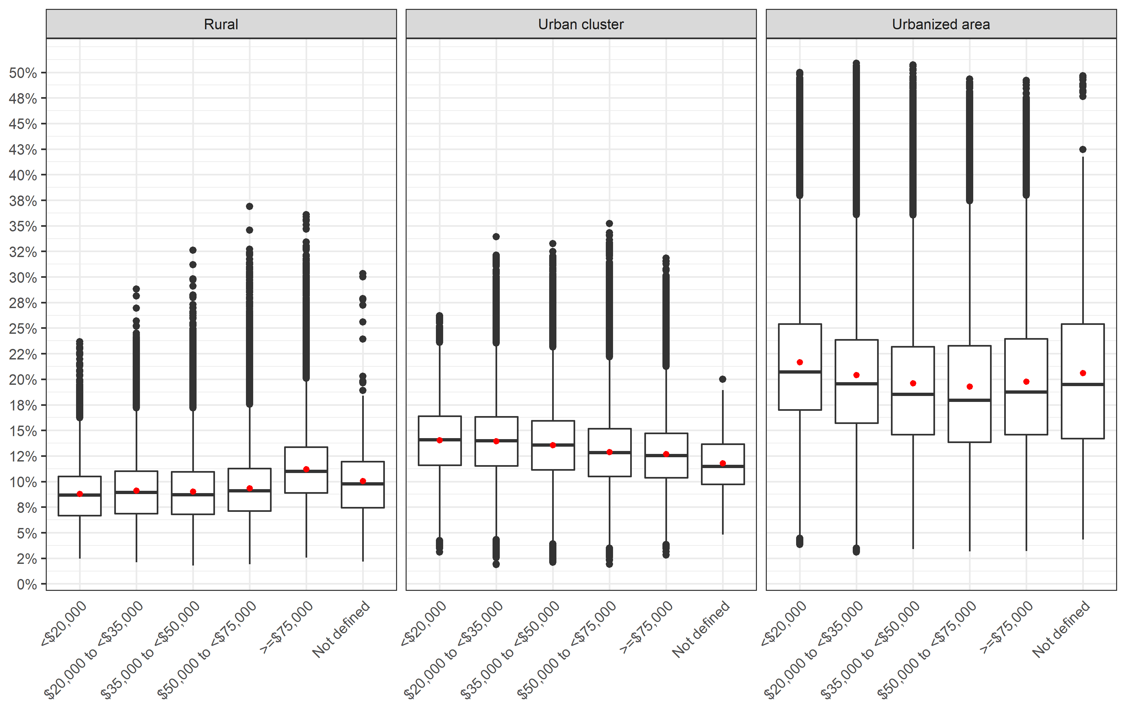

Figure 3: Attributable fraction by state

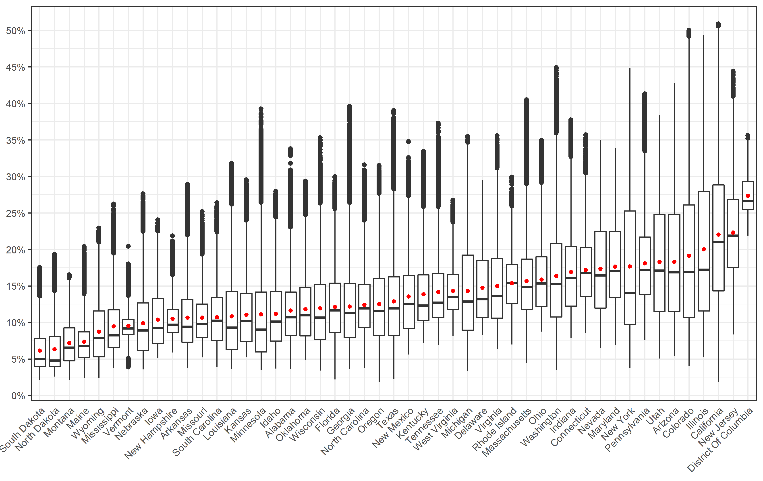

Figure 4: Attributable fraction by state and living location

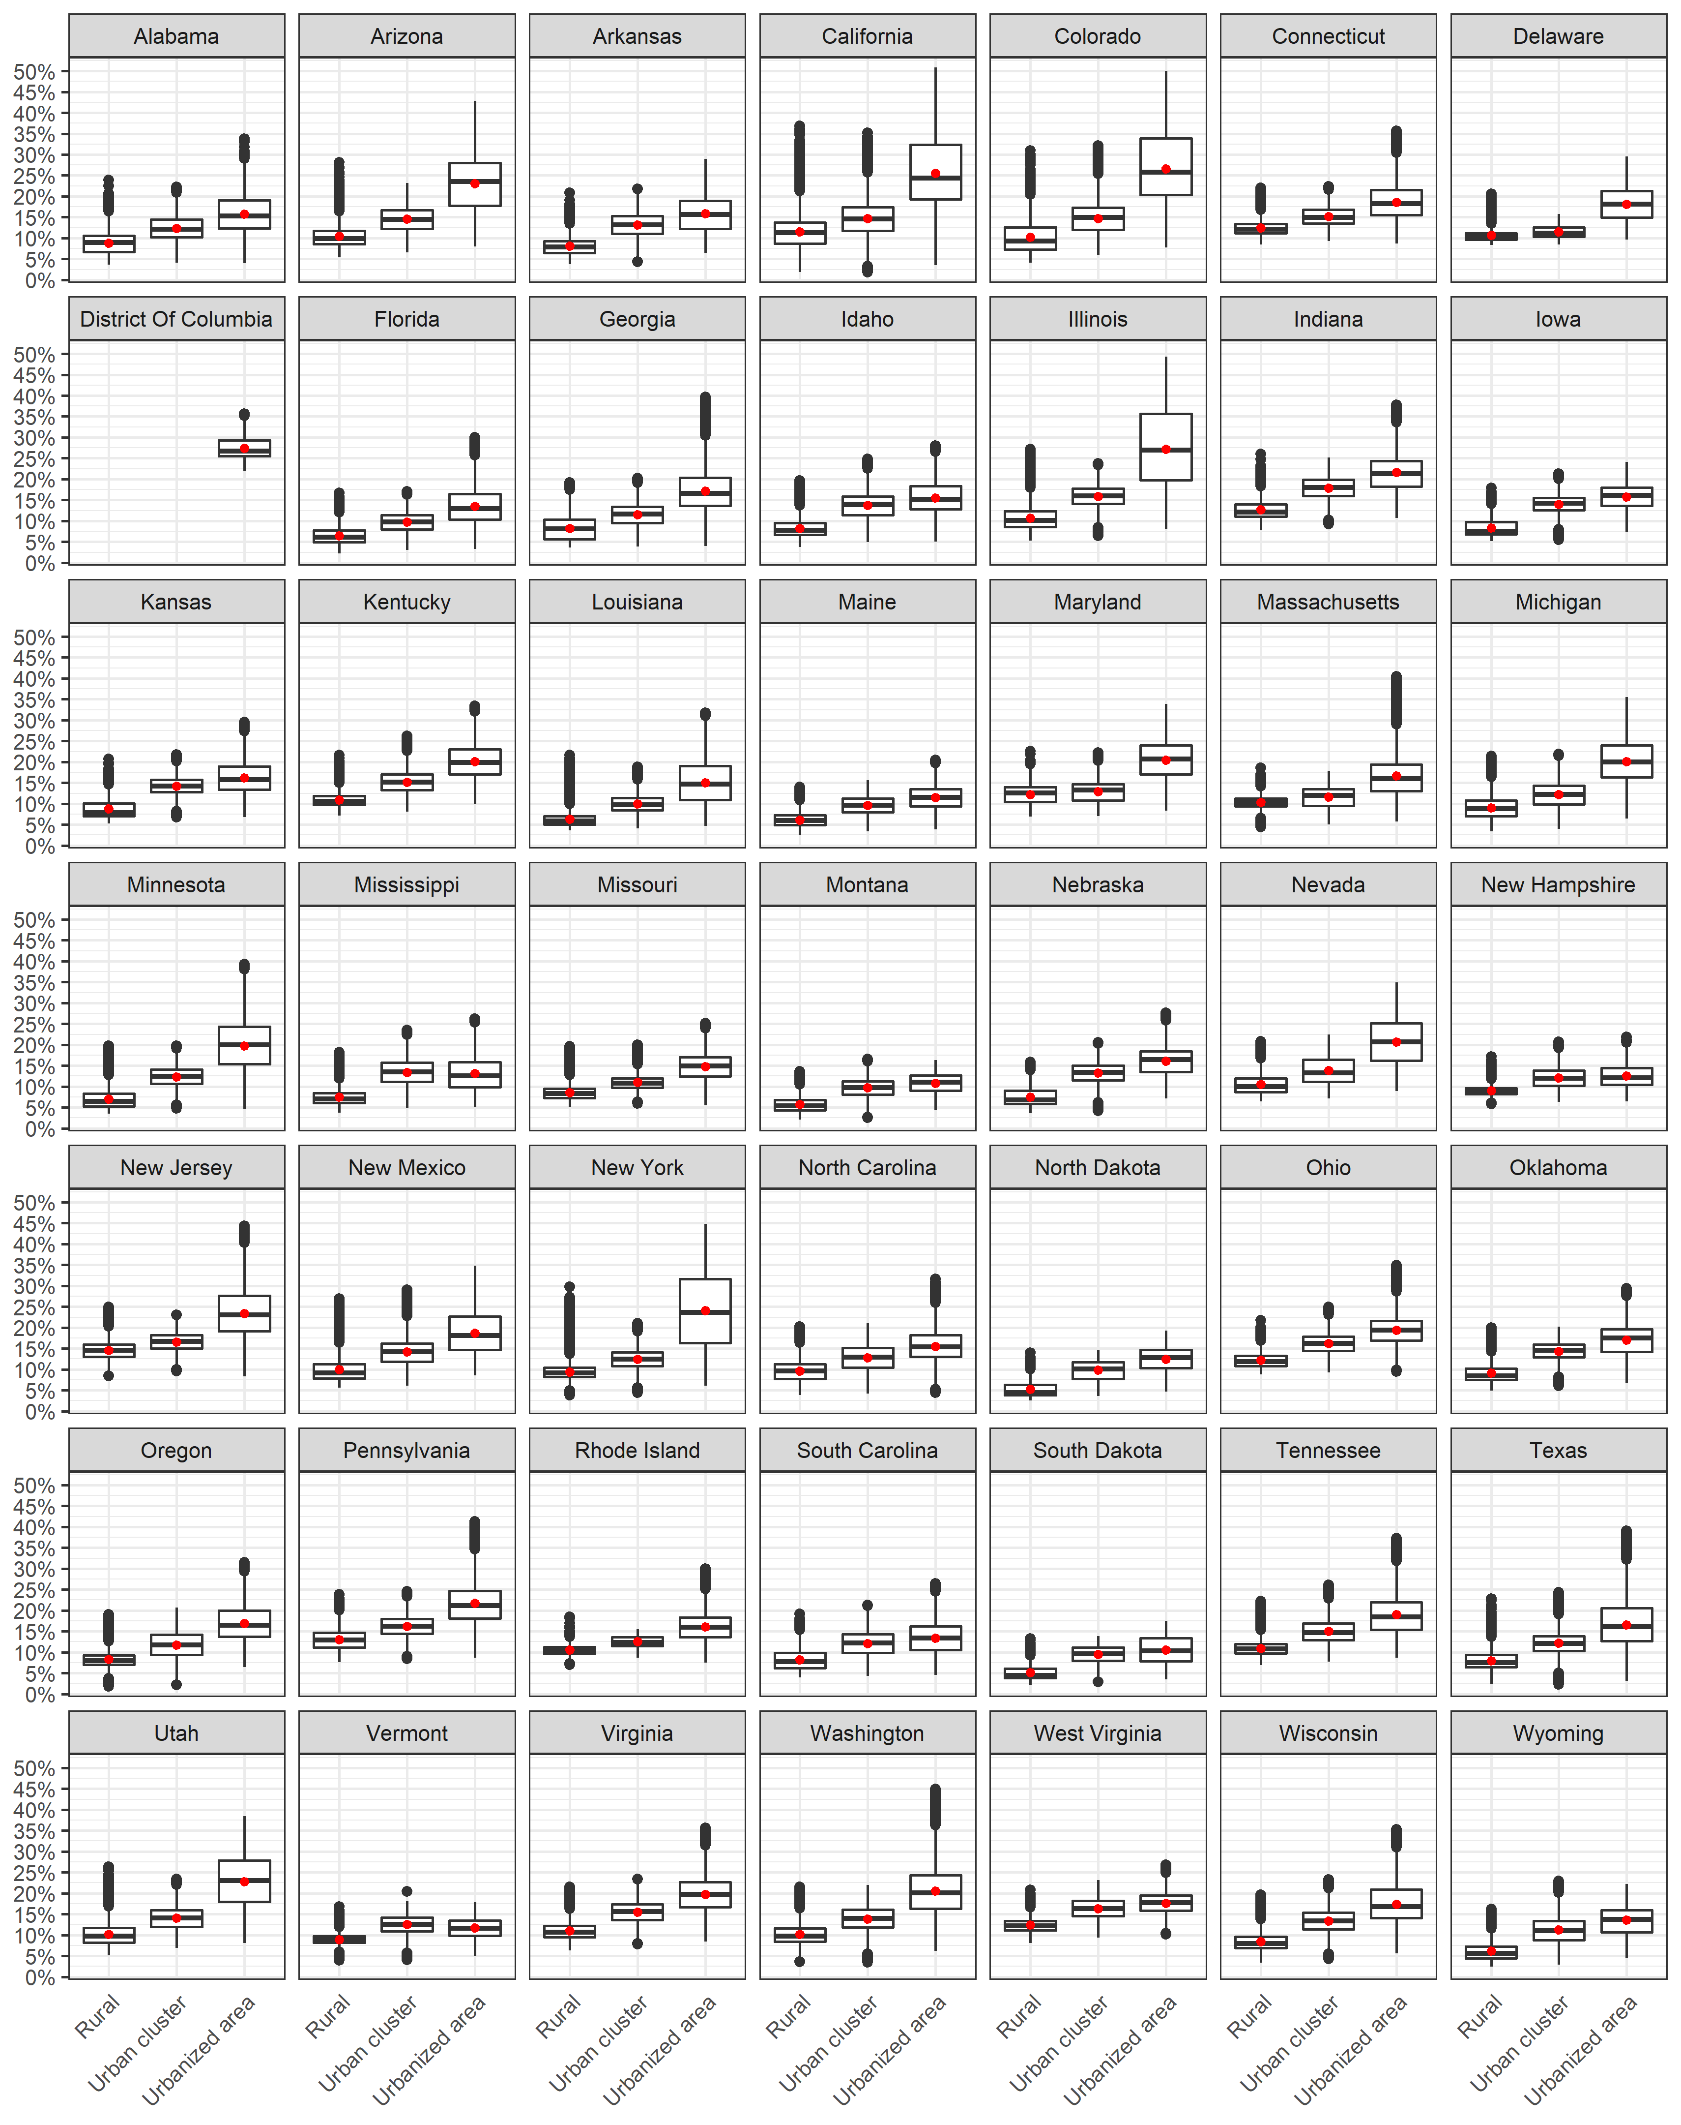

Figure 5: Attributable fraction by state and median income group

